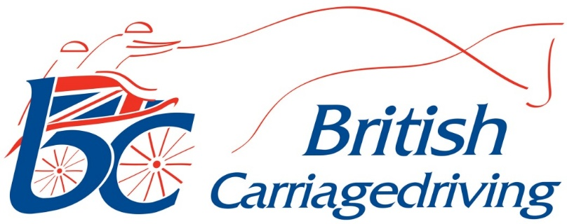

On 18th March 2026 Council for British Carraigedriving approved a change to the newly published 2026 Rule Book.
It was agreed that Paragraph 1.3.5 in Annex 11 about Vaccinations would be deleted.
It is no longer required for equines to have received a booster within 6 months + 21 days before arrival at the event.
It is still required that any booster is not administered within the 7 days prior to the event.
The remainder of Annex 11 remains in place. Please see the updated Annex 11 below.

ANNEX 11 HORSE PASSPORTS
1. Passports
1.1. All horses and ponies must have a recognised, statutory passport and unique identification number (UELN) in compliance with Government regulations.
1.2. On entering an event the equine information must be completed on line.
1.3. Vaccinations for equine influenza vaccines must be given in accordance with the following provisions:
1.3.1. All proprietary equine influenza vaccines are accepted, provided the route of administration complies with the manufacturer’s instructions (i.e. intramuscular injection or intranasal).
1.3.2. An initial Primary Course of two vaccinations must be given; the second vaccination must be administered within 21-60 days of the first vaccination.
Transitional Provision: Horses whose first vaccination (V1) of the primary course is recorded in the passport and dated before 1 January 2024 shall be deemed compliant with the previous requirements and are not required to restart the primary course, provided that the second vaccination (V2) was administered within 21-92 days of V1 and all subsequent booster vaccinations have been administered within the intervals required by these rules.
1.3.3. The first booster must be administered within 7 calendar months following the date of administration of the second vaccination of the Primary Course.
1.3.4. Booster vaccinations must be administered at a maximum of 12 month intervals, the same day in each year being acceptable for these purposes. If this period is exceeded, the vaccination course must be restarted as above.
1.3.5 DELETED
1.3.6. Horses may compete 7 days after receiving the second vaccination of the primary course.
1.3.7. Horses that have received the Primary Course prior to 1 January 2005 are not required to fulfil the requirement for the first booster, providing there has not been an interval of more than 12 months between each of their subsequent annual booster vaccinations.
1.3.8. Horses/ponies must be entered at all Affiliated Events and Shows in their registered names. Spot checks of identification, passport and vaccinations of horses/ponies will be carried out on the first day of the competition at all events on 10% of starters.
2. Penalties.
2.1. The following penalties will be imposed if any passports or vaccinations are not in order:
2.1.1. If the driver is not in possession of statutory passports for all his horses on arrival at the event, he/she will not be allowed to compete. If a driver is found to have competed with a horse without being in possession of a passport, a fine of £50.00 will be imposed, and the animals will not be allowed to compete in a National Event until the fine has been paid.
2.1.2. If the passport is not correct or, if the record of vaccinations is incorrect, these will be referred to a Veterinary Surgeon and, if confirmed to be out of order, the driver will be fined £50.00 but may be allowed to compete at the discretion of the President of the Jury. The identification document/passport must be in order and the fine paid before being allowed to compete again.
2.1.3. Horses and ponies not entered in the names shown on their passports will be allowed to continue to compete, but will be fined £20.00.

